****NASA Kelly twins study shows harsh effects of space flight and a brutal return to Earth****

****美国航空航天局凯利双胞胎研究显示，太空飞行和直接返回地球（会对人体）产生严重影响****

补充词汇知识

NASA

美国国家航空航天局

****全称****：The National Aeronautics and Space Administration

space flight

太空飞行

make oneself sth.

把…变成…

destination

n. 目的地

celebrated

adj. 著名的，有名的

****近义词****：famous

numerous

adj. 数量多的

****近义词****：many

including

prep. 包括

immune system

免疫系统

upon sth.

一…就…

as if

似乎，好像

concerned

adj. 和… 相关

****搭配短语****：as far as I am concerned

turn on

表达，激活

turn off

阻遏

****近义词****：repress

gene regulation

基因调控

fountain

n. 来源

****英文释义****：source

****相关词汇****：fountain （n. 喷泉、泉水）

slightly

adv. 稍微地

at risk

处于危险之中

**长难句解析**

In 2015, Kelly rode a rocket into space and spent nearly a year on the International Space Station in low Earth orbit, while his identical twin brother, Mark Kelly, stayed on Earth's surface for NASA's celebrated "twins study," designed to see what spaceflight does to the human body.

2015 年，凯利乘坐火箭前往太空，并在近地轨道上的国际空间站待了近一年。与此同时，为了进行美国航空航天局著名的“双胞胎研究”，他的孪生兄弟，马克·凯利，留在了地球表面。该研究旨在了解太空飞行对人体的影响。

这句话由一系列并列句组成，第一部分是 Kelly rode a rocket into space and spent nearly a year on the International Space Station in low Earth orbit，第二部分是 while his identical twin brother, Mark Kelly, stayed on Earth's surface for NASA's celebrated "twins study," 逗号后的部分省略了定语从句的关系词和谓语 that was 或者 which was，完整的说法是 for NASA's celebrated "twins study", that/which was designed to see what sapceflight does to the human body，其中 what spaceflight does to the human body 为名词性从句。

The full results, published Thursday in the journal Science, showed that Scott Kelly experienced numerous physiological and chromosomal changes during his long sojourn in orbit, including changes in gene expression.

周四发布在《科学》期刊上的完整结果显示，斯科特·凯利在（近地）轨道长期逗留期间，经历了许多生理上的和染色体上的变化，其中包括基因表达上的变化。

句子的主干是 The full results showed sth. ，published Thursday in the journal Science 为插入语，that 引导的宾语从句that Scott Kelly experienced numerous physiological and chromosomal changes during his long sojourn in orbit 就是句子的的宾语 sth.，在这里是研究结果的具体内容，逗号后的 including changes in gene expression 作同位语，补充说明了具体的变化。

学习资源

发表在《科学》期刊上的文章链接：[https://science.sciencemag.org/content/364/6436/eaau8650](https://science.sciencemag.org/content/364/6436/eaau8650" \t "https://shimo.im/docs/yrp3OV8P50jtxAmR/_blank)

NASA 双胞胎实验的官方网站：[https://www.nasa.gov/twins-study/](https://www.nasa.gov/twins-study/" \t "https://shimo.im/docs/yrp3OV8P50jtxAmR/_blank)

NASA 官方制作的实验结果一张图小结：

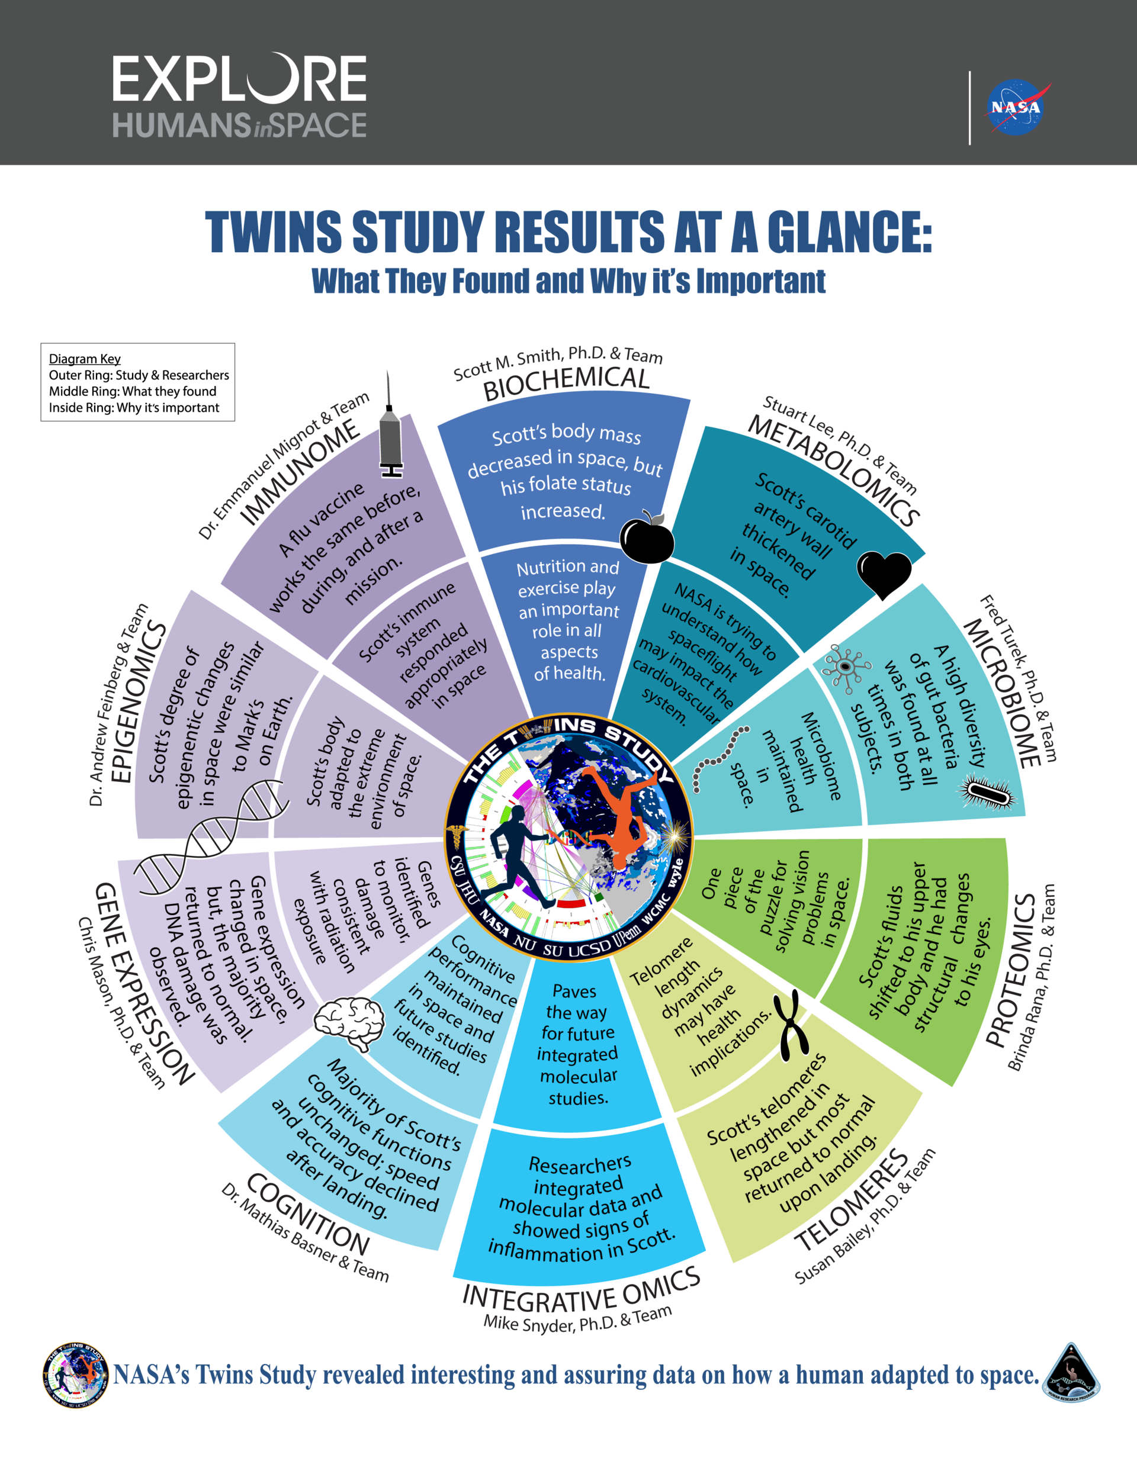

推荐的查音标网站：[https://www.oxfordlearnersdictionaries.com](https://www.oxfordlearnersdictionaries.com/" \t "https://shimo.im/docs/yrp3OV8P50jtxAmR/_blank)（牛津学习者词典）

英文引号的正确用法：[https://www.grammarly.com/blog/quotation-marks/](https://www.grammarly.com/blog/quotation-marks/" \t "https://shimo.im/docs/yrp3OV8P50jtxAmR/_blank)